System Parts
Disclaimer: This document only includes the bare-minimum hardware components
Raspberry Pi AI Kit – (The primary GPU/NPU for 30+ FPS 640x640 real-time object detection)
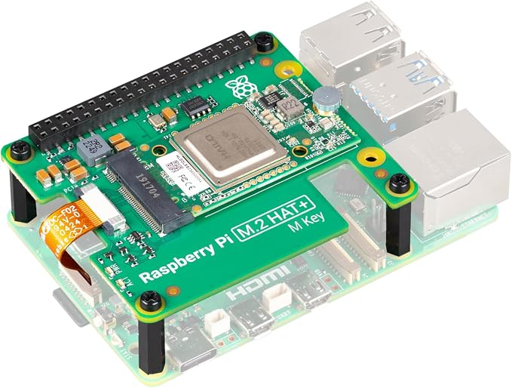

Raspberry Pi 5 – (Host SBC executing application logic, I/O routing, and model post-processing)
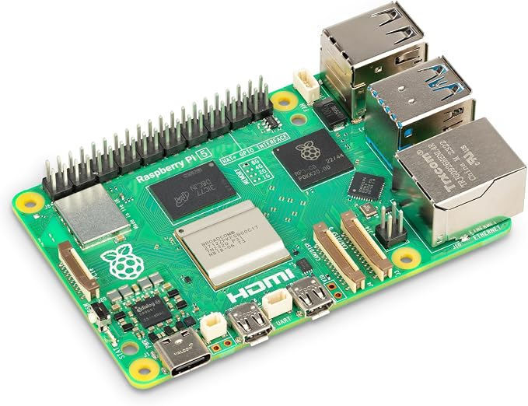

Logitech Brio 100 – (USB camera providing the 1080p video feed for real-time inference)
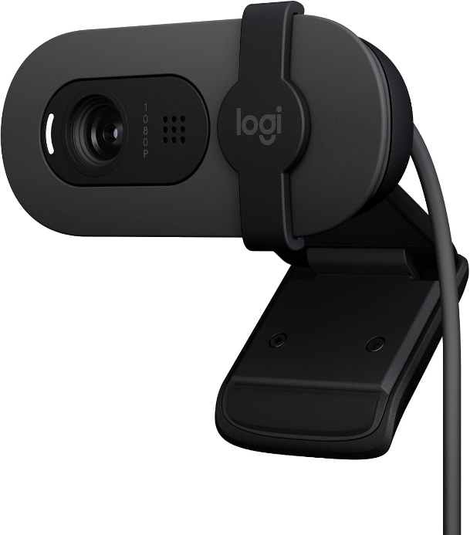

Logitech S150 USB Speakers – (Audio output device for real-time auditory alerts)
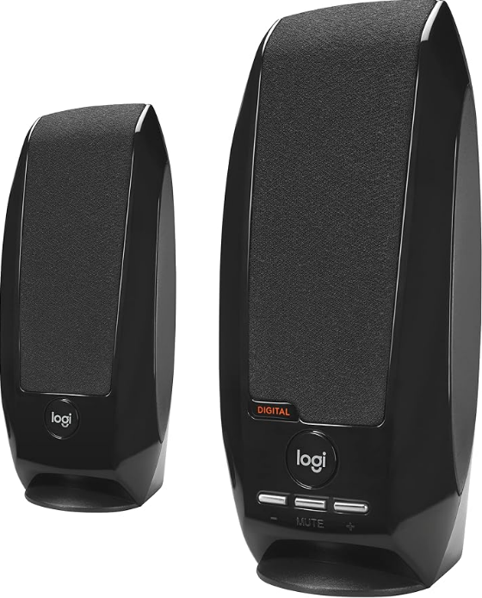

Raspberry Pi 5 USB-C Power Supply 27 W – (Provides 5.1V/5A power to sustain full compute load and connected peripherals)
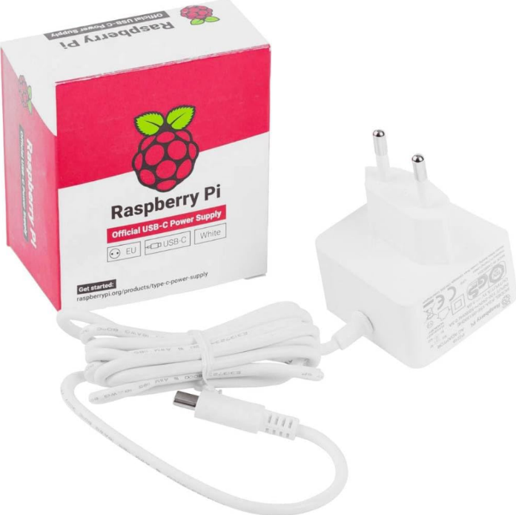

Raspberry Pi 5 Active Cooler – (Active thermal management preventing CPU throttling under sustained load)
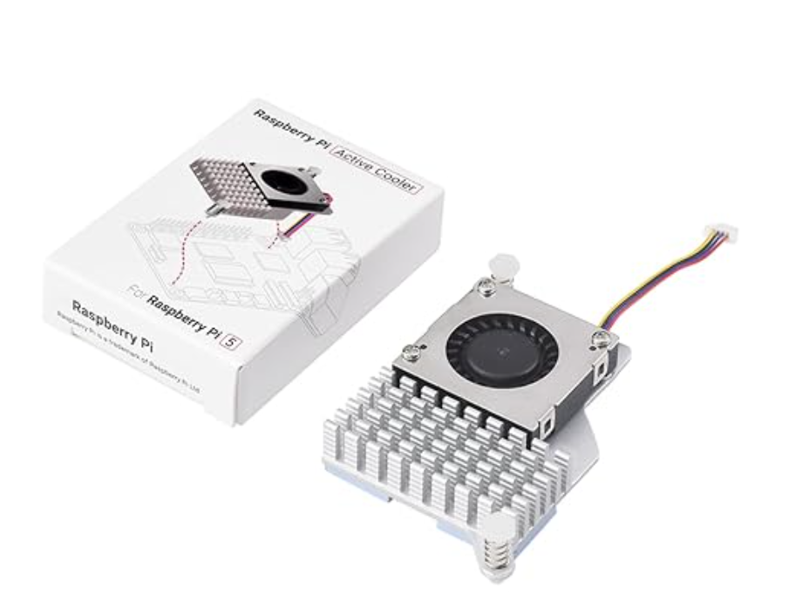

SanDisk Extreme Pro 64GB MicroSDXC – (High-speed storage hosting the operating system, code, and model weights)
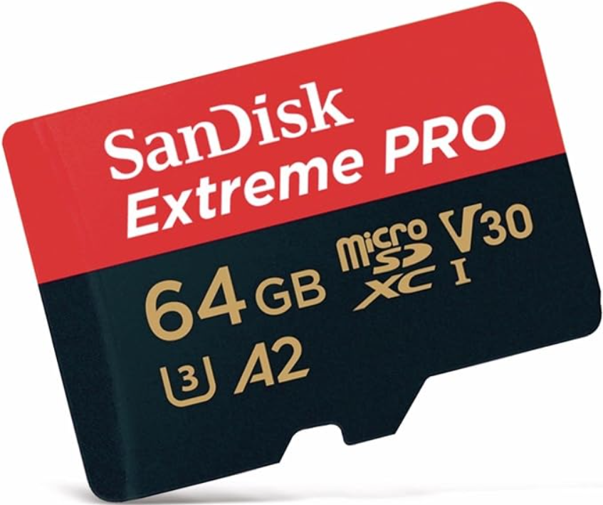

Raspberry Pi 5 Metal Enclosure – (Protective enclosure accommodating the Pi 5, active cooler, and PCIe Hardware Attached on Top (HAT) stack)
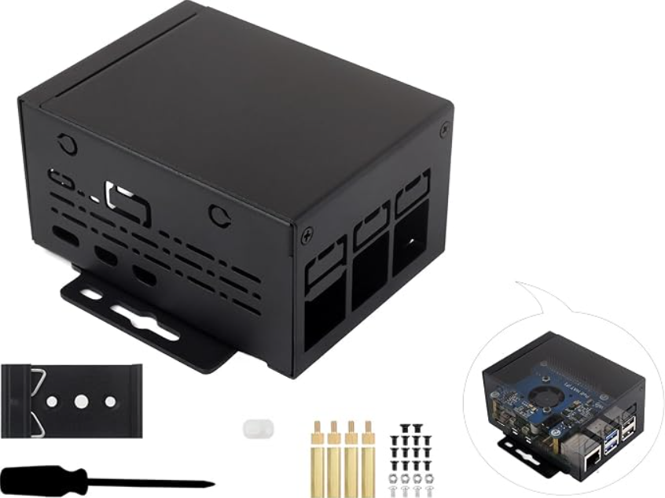

System Part | Price
Raspberry Pi AI Kit | 660 AED
Raspberry Pi 5 | 620 AED
Logitech Brio 100 | 125 AED
Logitech S150 USB Speakers | 80 AED
Raspberry Pi 5 USB-C Power Supply | 85 AED
Raspberry Pi 5 Active Cooler | 65 AED
SanDisk Extreme Pro 64GB MicroSDXC | 120 AED
Raspberry Pi 5 Metal Enclosure | 90 AED
Total | 1,845 AED

